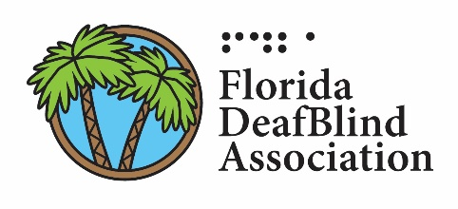

FDBA Membership Form

Types of Membership:
____ Active: $20.00
____ Associate: $15.00
____ Student: $10.00
____ Organization: $65.00

Want to donate? Please list the donation amount:
$_____________

Total amount of donation and membership dues: $_____________

Name: ________________________________________________________
City and State: ________________________________________________
County (Florida Only): _________________________________________
Email: ________________________________________________________

Please make payment payable to FDBA.
Mail the payment and membership form to:

Theresa Wells c/o FDBA
2151 Cherry Vale Place
The Villages, FL 32162

